Linux Introduction:

# Questions:

1. What are the different layers of Linux?

2. Explain briefly about three popular Linux shells?

3. What is the command used to get a guide on how to use a command?

4. How to get a list of currently running processes and resource utilisation in Linux?

5. What is a pipeline operator in Linux?

6. Explain file permission in Linux. How to change it?

7. What is the process in a Linux context?

8. What are Regular Expressions(regex)? What is the meaning of *,+,? In regular expression?

9. What is a sed command?

10. What is the difference between Hard Link and Soft Link?

11. What are Daemons?

12. Explain different file system types in Linux?

13. What are some of the major differences between these?

14. Name 25 of the most useful CLI commands

Challenge: install Arch Linux WITHOUT a graphical installer!

# Arch Linux Install + Tips

* Type ip link: To see if network interface is enabled and connected to the network
* Ping [www.etc.com](http://www.etc.com/) to check for internet connection
* Control C to kill ping
* # timedatectl set-ntp true → to ensure system time is accurate
  + to check system status type timedatectl status
* Now Partition the Disks:
  + If on physical hardware run lsblk to see what drives and partitions you have first.
    - In our VM, we have sda with 9.2GB of memory.
  + 1. Use cfdisk as it is easier than fdisk
    - * Select label type:
        + DOS(for VM) for legacy bios
        + GPT for UEFI Systems
      * Press Enter till you get to partition size.
      * Can create Multiple Partition# timedatectl set-ntp true
      * s Now
        + Create primary with 8GB (For eg, bootable. If you selected bootable there should be a * under boot)
      * Move down to free space → Create New → Primary → Type (To Change Type) 82: Linux Solaris for Swap Partition
      * Should now have dev/sda1 and dev/sda2 with respected types and sizes
      * Write Partition Table to Disk and type ‘yes’ (Partition table should be altered) → Quit to exit cfdisk
* Format the partitions:
  + # mkfs.ext4 /dev/sda1
    - Type lsblk to see if your partitions are there just in case
  + If we created another swap partition (which we did), initialize it through:
    - # mkswap /dev/sdX2
    - # swapon /dev/sdX2
* Mount the File Systems (No need to mount the swap)
  + # mount /dev/sda1 /mnt
* Select Mirror List ( With text editors: Vim or Nano)
  + Type nano /etc/pacman.d/mirrorlist
    - Delete lines through control+k, all mirrors except for the ones in your home country eg:Australia, control+O to save and control+X to exit, press enter after to exit
* Install the base packages
  + # pacstrap /mnt base linux linux-firmware→ Wait till it finishes
  + or pacstrap /mnt base linux linux-firmware base-devel vi grub dhcpcd net-tools iproute2(better way)
* Fstab: (File Sys Table)
  + # genfstab -U /mnt >> /mnt/etc/fstab
* Change Root in the System
  + # arch-chroot /mnt
* Set Time Zone: ls /usr/share/zoneinfo to see zoneinfo of your Country, ls /usr/share/zoneinfo/Australia to see zoneinfo of city
  + # ln -sf /usr/share/zoneinfo/Region/City /etc/localtime →
  + # ln -sf /usr/share/zoneinfo/Australia/Sydney /etc/localtime
  + Then Run hwclock(8) to generate /etc/adjtime:
    - # hwclock –systohc
* Localization:
  + # locale-gen
  + Create the locale.conf(5) file, and set the LANG variable accordingly [**THROUGH NANO OR VIM]**:
  + ***If nano or vim not installed through the root, type: pacman -S nano or pacman -S vim to install***
  + nano /etc/locale.conf
    - Then type : LANG=en_US.UTF-8
  + Set Keyboard layout (If you are using another language than english, if you are using english skip this step.)
    - /etc/vconsole.conf
    - KEYMAP=de-latin1
* Network Configuration:
  + Create the hostname file:
    - nano /etc/hostname
      * <Type hostname: eg, Adumbration>
      * Control+O, and Control + X to exit
  + Add matching entries to hosts(5):
    - nano /etc/hosts
      * 127.0.0.1 localhost
      * ::1 localhost
      * 127.0.1.1 myhostname.localdomain myhostname
* 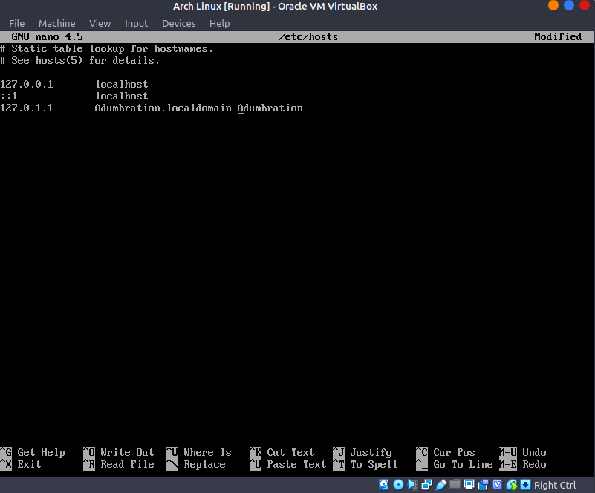Initramfs( Can Skip this Step)
  + # mkinitcpio -P
* Change Root Password
  + Type passwd
    - *Fbg etc.
* Extra stuff to do before reboot:
  + Network Config:
    - systemctl enable dhcpcd
    - Add new user(not root)
      * useradd -m benl
      * passwd benl
        + *Lje…
  + Install Sudo
    - pacman -S sudo
  + User Management, to add a member to other groups (wheel-root privledges,
    - usermod -aG wheel,audio,video,optical,storage, benl
    - To check: groups benl
  + Install Vim
    - pacman -S vim
    - then type visudo
      * Find the line: Uncomment to allow members of group wheel to execute any command
      * Delete the # in the line below it and :wq
* Install Boot Loader [Grub]
  + pacman -S grub →
  + grub-install */dev/sda →*
  + grub-mkconfig -o */boot/grub/grub.cfg*
* Now type “exit” to get out of chroot → Then type “shutdown now”
* Go to settings in arch linux VM settings, go to storage, and detach the archlinux ISO in controller:IDE, Power Arch Linux Again
* We have two logins (Adumbration and benl)
  + For benl type benl then pass *Lje..
  + ping google.com to see working internet. If not must install dhchdp from pacstrap /mnt base linux linux-firmware base-devel vi grub dhcpcd net-tools iproute2 line few steps above.
* Now you are ready for post installation:
  + Desktop Environment, Graphical etc.
    - Gnome, KDE, programs, text editor, file manager etc.
    - **sudo pacman -S xorg for graphical installation!**